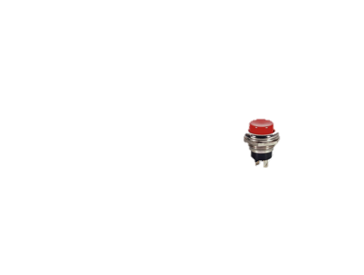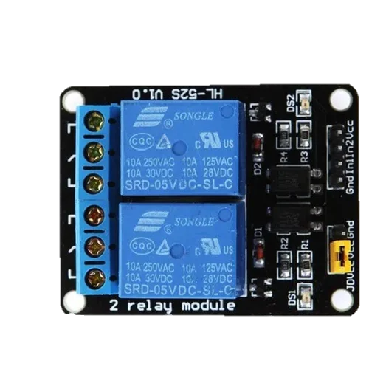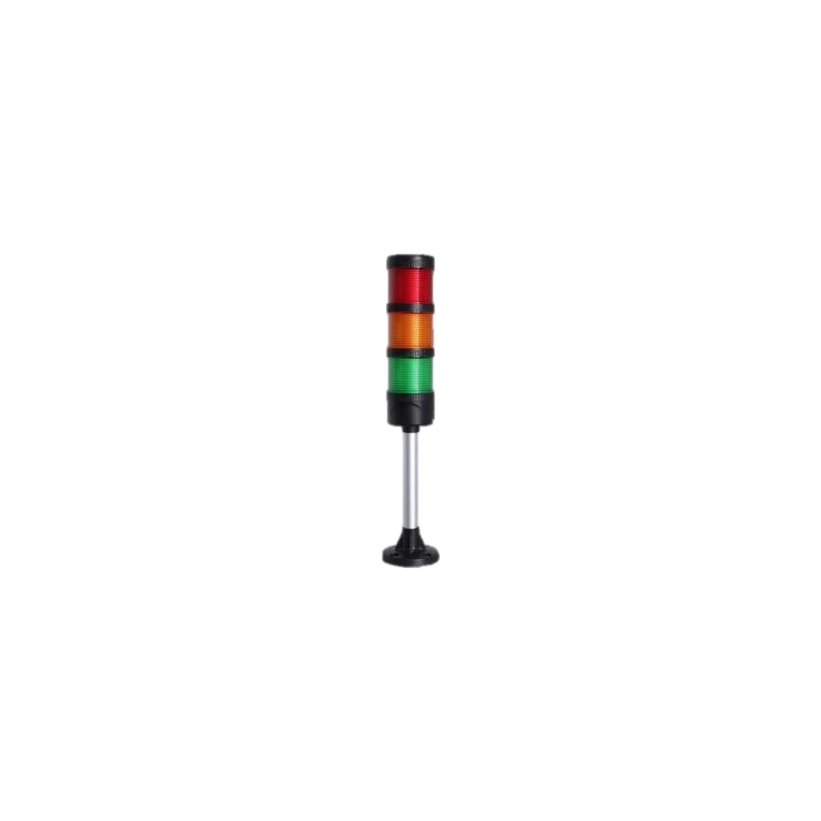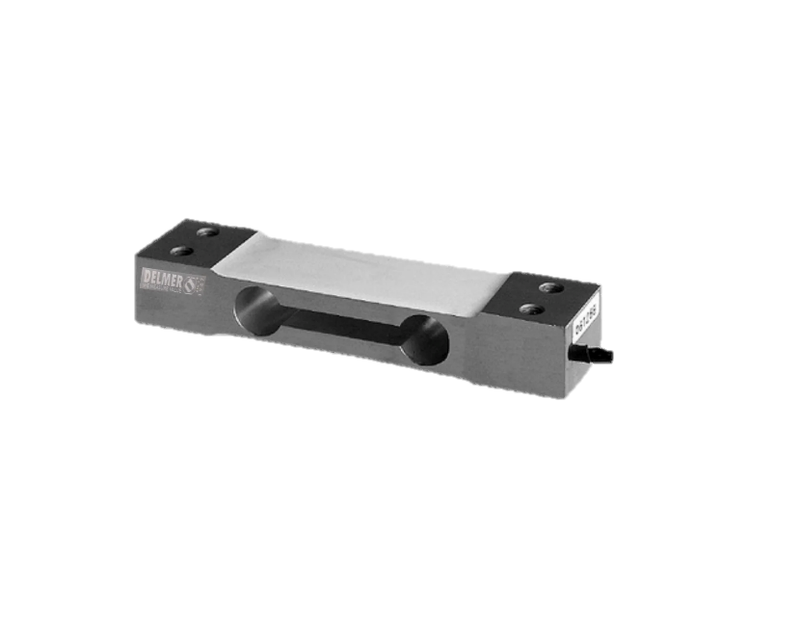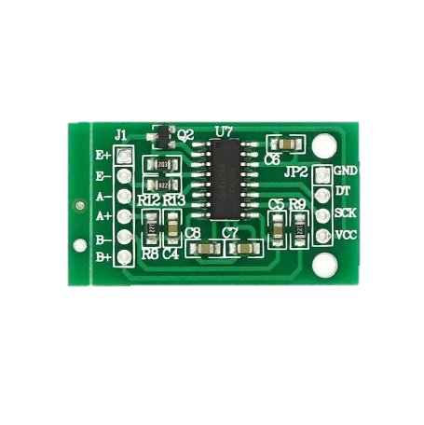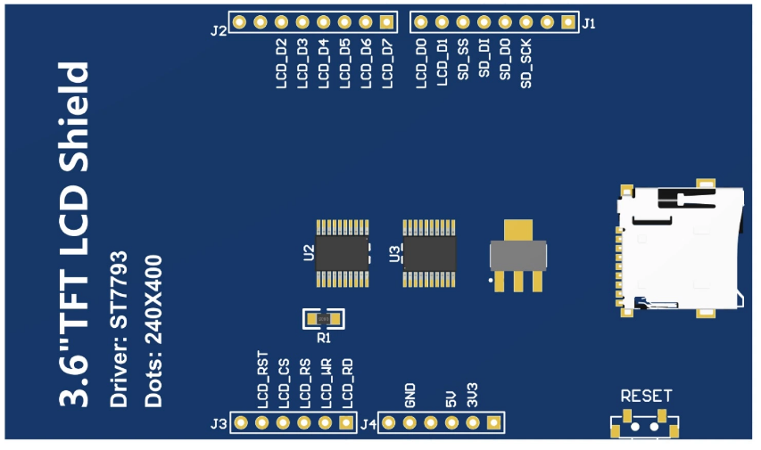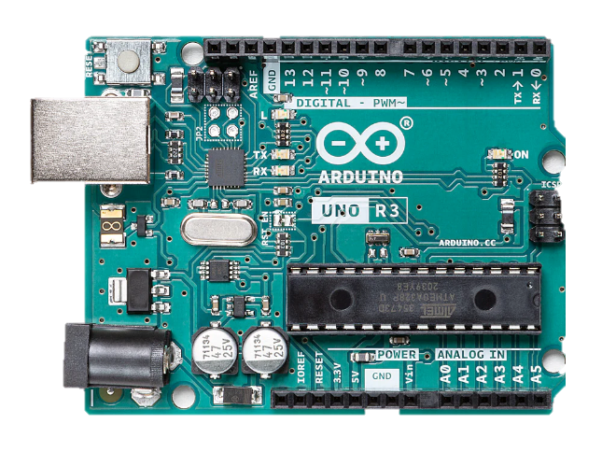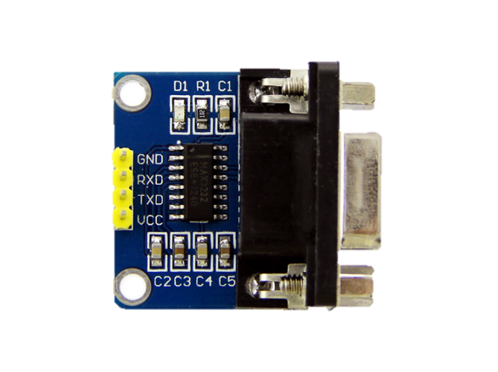

**SKEMA TIMBANGAN DIGITAL**

**IT NSI @ 2024**

BTN

PRINT = Klik 1 kali

TARE = Hold 3 detik

CALIBRATE = Hold 5 detik

LAMPU ANDON

ADAPTER RS 233 TO TTL

RELAY 2 CH

HX711

LOAD CELL